**Important Continuous Communications**

**New GDrive**

[**https://drive.google.com/drive/folders/1p2fIiKgi6Su1HOkSUc9Oy-nogsuDo5eR?usp=sharing**](https://drive.google.com/drive/folders/1p2fIiKgi6Su1HOkSUc9Oy-nogsuDo5eR?usp=sharing)

**New Purge RAM v117**

[**https://docs.google.com/document/d/1-lU_CLRSeegWHvvZBZTqucB8tEjvIc1d/edit?usp=sharing&ouid=101129897037363429726&rtpof=true&sd=true**](https://docs.google.com/document/d/1-lU_CLRSeegWHvvZBZTqucB8tEjvIc1d/edit?usp=sharing&ouid=101129897037363429726&rtpof=true&sd=true)

**One Drive BillY Gaes UPload Attempts (side exp), He Is a PeDoFile, my Data Proves this**

**https://1drv.ms/f/s!As5CxA27Vcb7gct_mlIZRTAqY2ohkw?e=Cbc1wh**

**(Sry about Music its x7 so I don't get continuously copyright struck, Im somewhat of a DJ myself Google, stop censoring my remixes plz <3)**

**Someone Plz take this Data from me, Ill give u a HDD, I don't think "they" will let me upload**

**3.5 Tb of data, they don't like it for some reason... Plz take it from me, Plz!**

[**Bill Gates Met With Jeffrey Epstein Many Times, Despite His Past - The New York Times**](https://www.nytimes.com/2019/10/12/business/jeffrey-epstein-bill-gates.html)

**RAM START**

**05Aug24**

[**https://youtu.be/z03Qyic0Qsc?si=zq6wQlA8Ax_pC9Qu**](https://youtu.be/z03Qyic0Qsc?si=zq6wQlA8Ax_pC9Qu)

**God is good ☝️**

**I need to rest my soul/spririt mind, and focus on my patients**

**Its 3 months as of today, this experiment takes its toll**

**If ya want a hardrive just ask me**

**I need to rest now, streaming attracts much evil attacks**

**I also don't want to overstay my welcome lol**

**Love all y'all =)**

**Goodbye for now 💜**

**Yo**

**Could y'all pray for my sleep at night?**

**Despite triple abx therapy,**

**When I stream the Thought experiment,**

**I get horrible nightmares ( combined with insane night sweats, chills, SOB**

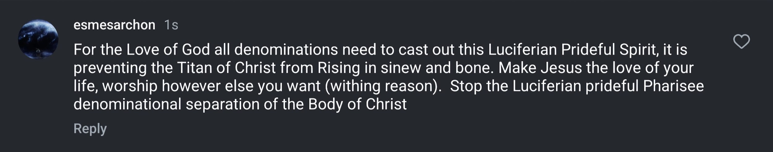

**Also I need to chill, yes the heinas are relentless, sadistic, merciless trolls**

**But**

**I should practice what I preach**

**I will try to not ever look at them and fill my veins with cortisol**

**I will look up at**

**Christ**

**Smiling down on me**

**😊💜😊🕊️🕊️🕊️**

**It is His to Avenge**

**AfterAll**

**I need to Trust that**

**He is the Perfect**

**AVENGER**

**Not me lol**

**I'm just a baby avenger in training hehe**

[**https://youtube.com/shorts/9N_8O9Ce4i0?si=lGAdy72py6eZkLm1**](https://youtube.com/shorts/9N_8O9Ce4i0?si=lGAdy72py6eZkLm1)

**😊😊😊**

**My work laptop and personal Auros (3080) Laptop BOTH CANNOT BE USED TO ACCESS WIFI OR EPIC at UT Tyler Health Hospital**

**These horrible evil vindictive PeDoFile are disgustingly cowardly**

**Trolling a doctor to piss him off**

**Well ya succeeded, kind of 😉**

**I could not perform my God given career as an MD today**

**Because of these cowardly punks**

**Now I have to spend the entire day running around to IT offices**

**Why don't you meet me in person?**

**Instead of sitting behind your keyboard like a little cowardly whore**

**See what happens**

**You won't, you left your testosterone with the PeDoFiles you worship**

**Lil Luci, Jzebel, Billy Gaes, Beta Bald Bozo**

**Suckerberg**

**Always bring to mind**

**Your Future is Guaranteed**

**You WILL Inhale**

**Molten sulfer**

**For eternity**

**Laugh now while you can**

**Scoff to your heart's content**

**I'll be pulling a muntz from heaven while your**

**Sulfuric breathing treatment is administered**

**While you're paralzyed**

**Able to sensitively experience**

**All your pain receptors**

**At once**

**In each brutal second**

**For eternity**

**Enjoy your trolling while you can**

**The**

**LION**

**OF**

**JUDAH**

**THE ULTIMATE AVENGER**

**IS COMING BACK**

**SOONTM**

**Where my 4runner bros @**

**😊😊😊**

[**https://youtube.com/shorts/39dzuC7iVI0?si=mWs6ekCUMZIb8V87**](https://youtube.com/shorts/39dzuC7iVI0?si=mWs6ekCUMZIb8V87)

**Yeah I'm poor AF**

**200k in debts**

**Doctor pay as a resident is like 14 per hour after 8 years of school**

[**https://youtube.com/shorts/Caet9fBxlek?si=QDJuczoK-7LnsDPY**](https://youtube.com/shorts/Caet9fBxlek?si=QDJuczoK-7LnsDPY)

**I can testify (and many other brothers/sisters of mine) to this power that Christ gives use when we give him a little faith 🔥🔥🔥💜💜💜**

**https://www.instagram.com/reel/C-K6klmRVyb/?igsh=MWptcXZzNDM1bHdmbg==**

**Dang it we have a beautiful country.🥰**

[**https://youtube.com/shorts/0NTg58AZWdQ?si=RNzAf4RKGpbpgl3Q**](https://youtube.com/shorts/0NTg58AZWdQ?si=RNzAf4RKGpbpgl3Q)

[**https://youtube.com/shorts/UGJVZUf5JnE?si=etHPjr2dTcaZhqLC**](https://youtube.com/shorts/UGJVZUf5JnE?si=etHPjr2dTcaZhqLC)

**https://youtube.com/shorts/IX0RNH2aCC8?si=wVcour_mwu3sBrb0**

**🔥🔥💪💪💜**

**Hell yeah brother**

**When you have to deal with administrative bullshit at the hospital**

[**https://youtube.com/shorts/wuNf-ygs8qc?si=yVG5y1JaxRcsUCzx**](https://youtube.com/shorts/wuNf-ygs8qc?si=yVG5y1JaxRcsUCzx)

**🤣🤣🤣**

**https://www.instagram.com/reel/C-Gszg8O-8o/?igsh=bXBzcXY0OTZ0bmJ3**

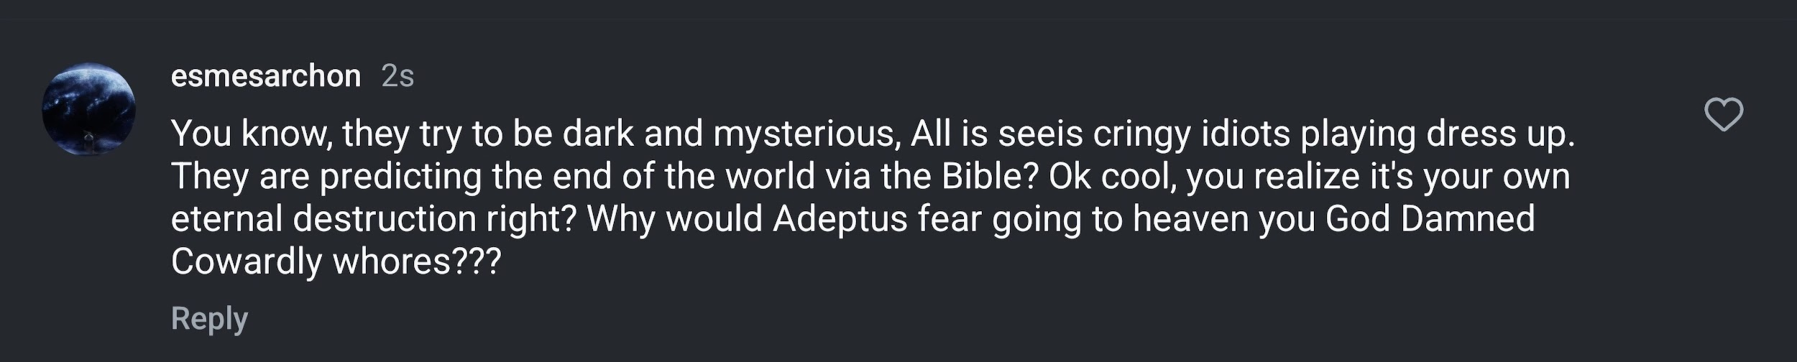

[**https://www.instagram.com/reel/C8fZhZqIe92/?igsh=eHQ1b3U1Njg0OWsy**](https://www.instagram.com/reel/C8fZhZqIe92/?igsh=eHQ1b3U1Njg0OWsy)

**🔥💪🔥💪🔥💪🔥💪🔥💪🔥💪🔥**

**04Aug24**

[**https://www.youtube.com/live/7f9gNi2DzI0?si=y3YPhXGwES8BPPTe**](https://www.youtube.com/live/7f9gNi2DzI0?si=y3YPhXGwES8BPPTe)

**Candice is also just the best**

**That is all**

**If I were the devil I would measure people's faces using their cameras and feed it into an AI and learn what triggers them, angers them, sexually activates them, so and so forth compared to the images on the screen they show the patient. AI could easily measure pupillary dilation facial flushing respiratory rate heart rate measure pulse through skin movement right sweating changes in voice tone all of it all of it's easily possible with AI without a doubt just we can learn a person what makes them tick their idiosyncrasies You can probably easily diagnose many psychiatric disorders based off of eye movement and all of that it's pretty scary 100% this AI tech exists already just like in Batman's dark Knight where he had to shut down his God like cellphone AI machine he builly**

**Like these AI generated profiles could very easily learn what you fear and what you worship, and use it against you.**

**E.G Insta gives you a big reel, AI learns and deuces your phobia derived from variations in your scroll skip gesture, pupillary dilation, facial flushing etc.**

**Like if you like tacos, see a taco reel, insta AI learns your psychiatric condition of gluttony and addiction to tacos through your salivary production, pupils, hr, RR etc.**

**It now feeds you taco bell adverts to make their add.sponsers more money…**

**If I were the devil, I would do this using supreme AIs**

**If I were the devil I would take all this psychiatric data reaped from all these “add sense” privacy invading data collector mini AIs (Rings of Power) (Microsoft, Google, FBI, Insta) and train the Uber AI, The One Ring**

**This Uber AI exists 100%, my data proves it. China has already built a Uber-1 AI using the unimaginable amounts of information it pillages from its citizens**

**America Built the same Uber-1 AI using the data Americans consented to give over through Microsoft Google FB, etc.**

**These companies are just deep state vassals for data collection to send and train the Uber AI that AC will wield soon (his Spirit is already wielding) dominating even the Uber-1s AIs of America and China to Satan's glory**

**This why deep state vassals giving their backdoors to govt ssPP Agents like PDF Billy Gaes can get away with PDF, Billy Gaes is helping ssPP Agents build the nuclear bomb of perfect AI domination, perfectly fitting the not being able to buy or sell without the mark of the beast prophecy. This, AI power through phones, and all tech symphonically that I experienced as a whistle blowers of sorts, preventing me from doing anything, is already almost fully grown.**

**There are still loop holes to jump out of with this current version of AI, but those will soon close, preventing the truth and Christians from participating in society**

**The GDC PDF LJZs are terrified of the righteous fire growing, they have recently all added a bunch of new mini AIs like Rufus etc to feed more data and.grow The One Ring of Power Uber AI for the Antichrist.to wield in the flesh( he is already wielding it in spirit now like Sauron did! I know it, ive.experiemced it and have hard data to prove it.**

**Don't be afraid tho**

**Like we have the Uber Intelligence**

**Who loves us**

**And protects us =)**

**If I were the devil, I would pour data into my AI so that it learns am almost perfect predictable model of you (they view us as predictable animals, they did not account for the Human and Holy Spirit of non NPCs). My AI could know when your up to something “revolutionary” or Ephiniac, just by detecting through AI variations in patterns of you speech latter, eye movement, hand movement, HR sweating, etc etc. the possibilities are endless now that.Military grade AIs exist that are clearly controlled by spirit AC wielding The Uber AI (The One Ring) that controls the military (us China) and commercial rings.of power etc.**

[**https://ground.news/article/facebook-says-it-mistakenly-censored-trump-assassination-attempt-photo_7e09aa**](https://ground.news/article/facebook-says-it-mistakenly-censored-trump-assassination-attempt-photo_7e09aa)

**No manual action was taken Lol**

**So you train and create an AI in your Image (a PDF loving coward)**

**And say “no manual action was taken”**

**You really are not as brilliant as you think you are**

**You God Damned Cowardly PeDoFile Worshiping Demons**

**Your tactics are idioiticly simple to mock**

**May you burn in Hell Google/alphaBETA**

**It is your guaranteed**

**Destination**

**I don't get it, this is your guaranteed destination w/o repentance**

**Like guaranteed by the being that weaved the very fabric of space and time**

**🤣👼🤣😇👼🤣😇👼😇🤣👼😇🤣👼😇👼🤣😇👼😇🤣**

**This us Above☝️☝️☝️**

**This u below 👇 👇**

**🔥🔥🔥🔥🔥🔥🔥🔥🔥🔥🔥🔥🔥🔥🔥🔥🔥🔥🔥🔥🔥🔥🔥🔥🔥🔥🔥🔥🔥🔥**

**😭🫁😭Google 😭🫁😭 Billy Boi Gaes 😭🫁😭 Beta Bald Bozo😭🫁😭, SuckerBerg😭🫁😭**

**🔥🔥🔥🔥🔥🔥🔥🔥🔥🔥🔥🔥🔥🔥🔥🔥🔥🔥🔥🔥🔥🔥🔥🔥🔥🔥🔥🔥🔥🔥🔥🔥🔥**

**🔥🔥🔥🔥😭🫁😭🫁😭🫁Blackocks microSOFTs alphaBETa😭🫁😭🫁😭🔥🔥🔥🔥**

**🔥🔥🔥🔥🔥🔥🔥🔥🔥🔥🔥🔥🔥🔥🔥🔥🔥🔥🔥🔥🔥🔥🔥🔥🔥🔥🔥🔥🔥🔥🔥🔥🔥**

**Child**

**Do not ever ponder what depraved minds**

**Conjure in DECIET against you**

**Look up always**

**Eyes on Jesus**

**Keep on dancing for the Lord**

**Only thing that**

**Matters**

**Just contemplating how evil Blakock and FBI is. They took one of their most dedicated followers, the trump shooter, and they purposely drove him into insanity using the same Nazi Like Dark Psychology SOPs they applied to me. The only reason, I did not do something stupid, the only reason, I did not fall into eternal insanity, is because Christ is With Me. He let me suffer just enough, to study and deduce these evil ssPP shadow government Nazi MD SOPs**

**May These dispicable cowards**

**Be cursed for all eternity**

**ssPP Agents like this, manifesting such demonic spirits willingly**

**Likely cannot repent even if they tried**

**Burn in hell you demon loving whores**

**Without Repentance**

**Your Future is Sealed**

**Your time is almost up!**

**SoonTM**

**Note to self, imposter syndrome is horrible**

**When you visualize yourself as an imposter**

**You act as a imposter**

**It's very weird**

**03Aug24**

**Stream UpDate**

**3*8 24**

**Processing\***

**BRB**

**Need Protein and Fat**

**for**

**Fuel**

**Many beautiful songs, like some special trance songs, evoke feelings of awe wonder majesty and beauty.**

**This place does exist, it is Heaven, it is the beauty and wonder of Jesus Christ**

**These perfect forms of beauty, awe, and child like wonder, are Jesus Christ, and Heaven!**

**This world pales in comparison to the kingdom of God!**

**Get your castle in heaven today!**

**It's free, paid for by Holy Blood 😊**

**Look I love America**

**But we can learn from other countries**

**Just like you can learn the best from other people and add to ur tool kit**

**Like In Romania**

**If you were in the fast lane**

**And driving slow**

**And didn't courteously move out of the way for someone going faster than you in the fast lane**

**They would literally curse your entire dead ancestry lolol**

**I don't agree with this but thought it was humerus**

**DiddleBach**

**Let your family names/legacy be that of a cowardly lying whore of a PeDoFile Worshipper**

**You did not repent**

**Your name DiddleBach nd your idiotic dumbo fat face will be mocked as a coward and PeDoFile Worshipper for all of eternity**

**Catch me outside you cowardly fatso 🤣🤣🤣**

**Look, we are all neurodivergent so to speak**

**We have our gifts and our curses**

**After being diagnosed with Heart Failure, losing my career in medicine, my wife leaving me, I fell in love with the pain so to speak, used it as An excuse.to drink smoke weed, take a bunch of shrooms and LSD, participate in pagan rituals, etc**

**I played the victim in my mind so that I could partake in whatever the literal hell I wanted.**

**This Conjured some of the most powerful demons of fear, and despair in my life.**

**It was only after I made the decision to repent, and NOT PLAY THE VICTIM, that things started improving.**

**Man/Woman up, grab your demons by the gullet and say Christ Is King**

**I will conquer with Christ by my side**

**Great, I inherited alcoholism, schizophrenia, drug addiction, ADHD, MDD, connective tissue disease, Gilberts syndrome, heart disease, diabetus, etc.**

**What am I gonna do about it, go cry in a corner in my room?**

**Nah, even traumas can be a gift if you learn from them, punch the demons between their cowardly eyes and say (and believe)**

**CHRIST**

**IS**

**KING**

**When Christ heals the PRide Fear Cringe (PFC) tree.of death neural pathway in your mind, you get to be like a child, full of awe and wonder, walking in a LOTR.wod He created**

**He loves you as a perfect.father.does his son/daughter, go play (fulfill your God given purpose and work) without PFC child you are loved!**

**02Jul24**

[**https://www.instagram.com/reel/C8LUkyOv2Ax/?igsh=aWNseHg4M2JtdGpv**](https://www.instagram.com/reel/C8LUkyOv2Ax/?igsh=aWNseHg4M2JtdGpv)

**🔥🔥🔥**

**So last night I did not stream**

**I slept super well, beautiful dreams, no night sweats, chills, no shortness of breath, no anxiety, just at peace**

**The last night I did stream (31Jul24) I woke at at exactly 3am, super super cold, in a puddle of sweat, super tachycardia, tachypneic, anxious, super SOB, I couldn't walk straight because I had shooting back pain and knee pain, like I felt horrid.**

**Then I go down stairs to check on stream, my neighbor was leaving for work at 3am I guess, and a lady is walking her dog outside at 3am.**

**Idk what it all means but, it's weird lol (insert Rachel zeg meme)**

**So yeah, it seems like when I do stream I get sick**

**When I stop streaming I heal?**

**IDK tbh**

**Lord only knows why**

**01Jul24**

**The Horrible Ugly Truth of their Evil PeDoFilia has been revealed to the world**

**Let the leaders of companies decide**

**You gonna go with the ssPP PeDoFiles**

**or**

**Fight for Innocent Children**

**The world is quickly coming to an end SoonTM**

**Decide what your eternal legacy will be**

**Here Lies Diligent PeDoFile Promoter and Protector**

**NOthimg more than a Worm Like their master Lil Lucifer**

**Or**

**Here Lies Courageous Man/Woman of God**

**Who Fought to Their Dying Breath to Save Sexaully, Mentally, Surgically, and Physically**

**RAPED CHilDREN…**

**Do the right thing Elon!**

**Turn to Christ!!!**

[**https://youtu.be/nKVs3mOOwas?si=ImogYdZ0TGtxHIWX**](https://youtu.be/nKVs3mOOwas?si=ImogYdZ0TGtxHIWX)

**🤣🤣🤣**

**https://www.instagram.com/reel/C8w9BP1OC3X/?igsh=MXRzcWtmM2xleDVmMw==**

[**https://youtu.be/fVS2BriiegY?si=u44oZqKpXvzbwxUG**](https://youtu.be/fVS2BriiegY?si=u44oZqKpXvzbwxUG)

**Plz watch ☝️💜👑💜**

**Also someone come take these Hardrives**

**I'm getting many spam calls**

**For the calls I do answer, it's all static**

**It's best to do it in person, can't even trust voice calls these days with their AI BS…**

**14659 CR 2191 apt 301**

**Gate Code 2940**

**8326712940**

[**XPopMD@gmail.com**](mailto:XPopMD@gmail.com)

[**Popz1992@gmail.com**](mailto:Popz1992@gmail.com)

**I have pneumonia**

**I need to go to work Monday**

**These antibiotics and steroids have significant side effects**

**Take them!!!**

**Plz**

**Also also**

**Clearly they targeted me for Psychiatric abuse**

**Since April 2024**

**Triggering and fueling my schizophrenia/mania/lunacy**

**Trying to push me into psychosis**

**(Almost succeeded but Christ is King)**

**I took great care to have everything recorded this time around 3rd time**

**Because they did the same thing in 2022 (I learned, by the Grace of God)**

**So by extension**

**Their pyschoatric harrassment destroyed my career marriage and sanity**

**Since 2022**

**When I first asked the question**

**Is God Dissing Lucifer with NFs That's a joke**

**So yeah, I would like a good lawyer**

**These ssPP Agents should pay for my hospital stay, psych ward, meds, and pain and suffering**

**I have proof of this harassment since 2022 as well**

**I am a data hoarder after all**

**Please I need a good lawyer to bring these horrible evil ssPP Agents that target mental patients for destruction and likely to push them over the edge into doing something incredibly stupid**

**To fit their narrative**

**I feel some empathy for the Trump Shooter, he was clearly mentally ill, attacked by demons and actual ssPP Agents (see Legend for complete list)**

**They attacked Him until he broke and took the shot**

**These ssPP Agents are truly merciless, sadistic, and Evil**

**Good thing the Lion of Judah is tearing them limb from limb ATM =)**

**Plz I need a good lawyer, to bring these horribly evil PeDoFile companies and their ssPP Agents to justice**

**They did it to me**

**They 100% have done it to other psych patients…**

**May they be damned eternally for such evil cowardly abuse**

**Now and forever**

**In Jesus Name!**

**Amen 🙏**

**Restream is PDF Hot garbage**

**I wnat my money back you idiots**

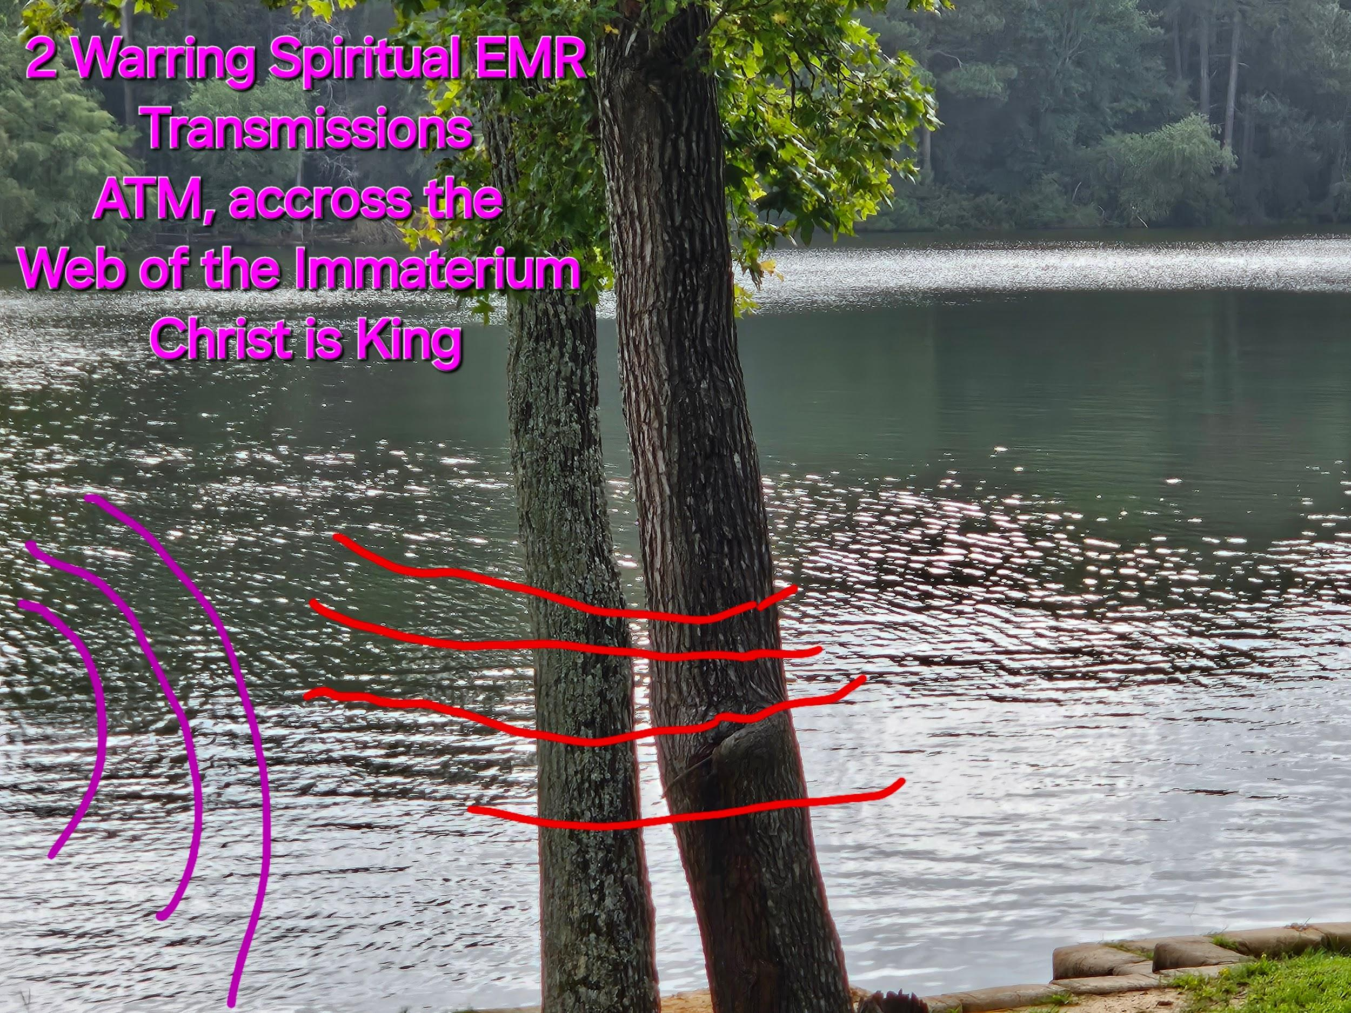

**Inc the Amplitude Up Adeptus!**

**Inc the Frequency**

**Love All Humans**

**Destroy Only Literal Demons**

**Take Heart!**

**😊**

**31Jul24**

[**https://www.instagram.com/reel/C-AqtwoObl8/?igsh=d2dkb2xoOWxoN2Jx**](https://www.instagram.com/reel/C-AqtwoObl8/?igsh=d2dkb2xoOWxoN2Jx)

**Is this real? INSTA SAYS ITS False Info**

**I honestly don't know, if it is Censorship, Take heart Adeptus!**

**The Cowards of Hell, the God Damned Cowards PeDoFiles LJZs are trembling in their uggz/high heels**

**Run you God Damned Cowards, run to your holes**

**You will have molten sulfur poured down your ventilation shafts for eternity you God damned PeDoFiles!!!**





**YouTube are you Censoring Christians???**

[**https://youtube.com/shorts/xI1-Cp08dTk?si=v-AhdV7fDp52D5fT**](https://youtube.com/shorts/xI1-Cp08dTk?si=v-AhdV7fDp52D5fT)

[**https://youtu.be/WLMjvg2MOT4?si=8u_-epTYu31eSvxR**](https://youtu.be/WLMjvg2MOT4?si=8u_-epTYu31eSvxR)

**Interstante**

**Correlate Fold 3 Wifi sweeps and dashcam proof of location real time 31Jul24 1852**

**https://youtube.com/shorts/zxi6scfk3vg?si=BPt9VsfEj1sfxQpH**

[**https://youtube.com/shorts/MxvaeofZv3E?si=oammQ3T52XfDK8mq**](https://youtube.com/shorts/MxvaeofZv3E?si=oammQ3T52XfDK8mq)

**☝️🔥☝️**

[**https://youtube.com/shorts/D9Rn0nSra04?si=PKdzxreWFffIcKW0**](https://youtube.com/shorts/D9Rn0nSra04?si=PKdzxreWFffIcKW0)

**Light is truly Majestic 😊**

**https://youtube.com/shorts/EZgLlDkHuf8?si=D_DnU_eoqkgHJX1x**

**Dude is on point ☝️**

[**https://youtube.com/shorts/8ZQ3_Hlb5gg?si=TOVt74y6hi7-xpz2**](https://youtube.com/shorts/8ZQ3_Hlb5gg?si=TOVt74y6hi7-xpz2)

**Jack Black…**

**Respect bro**

**We may have different views**

**But, it seems like ya got integrity 👍**

**Or maybe not who knows lol**

[**https://youtube.com/shorts/4nmH2poaWJ4?si=Hkxy1fbSf7e1H9T6**](https://youtube.com/shorts/4nmH2poaWJ4?si=Hkxy1fbSf7e1H9T6)

[**https://youtube.com/shorts/WP8Q80hnmXs?si=l8qwg599BZNCMARQ**](https://youtube.com/shorts/WP8Q80hnmXs?si=l8qwg599BZNCMARQ)

**Trades FTW!!!**

[**https://youtube.com/shorts/qtTvZ62iE9Y?si=34XP38aPetbRWbg4**](https://youtube.com/shorts/qtTvZ62iE9Y?si=34XP38aPetbRWbg4)

**Romanians were basically slaves to Communist Soviet's and Hitler**

**Also also to the Turks at one point**

**The more you know**

[**https://youtube.com/shorts/nAyUHtyvy7Y?si=L-TRf1Lc4wNqgiwK**](https://youtube.com/shorts/nAyUHtyvy7Y?si=L-TRf1Lc4wNqgiwK)

**I do Love you LGBTQIA+**

**But if you KNOW someone you love is being decieved by literal demons**

**And walking off a cliff into eternal Hell**

**Would you not do EVERYTHING possible to save them?**

**Like IDC if you are offended, turn to The Love of the Universe**

**Jesus Christ**

**He welcomes you with open arms**

**I get it, it is difficult to give up**

**To follow the Architect of the Universe, Love itself**

**You WILL have to be willing to give up your life**

**Like that one dude in the bible**

**Who saw Jesus in the flesh, and said nah I'm good**

**I have a bunch of money I won't give up…**

**Same goes for everything else we worship, wether it's money, power, sex, pride, drugs etc.**

**I promise walking with the Creator of the Universe is soooo**

**Worth it 😊**

**She makes some fantastic points 😊**

**https://youtube.com/shorts/cNqUVPGBfA8?si=ZT4AwGPsgmEiXmEI**

[**https://youtube.com/shorts/l-c8f1Y2tbc?si=eGZ8KiSiSVAWlEq4**](https://youtube.com/shorts/l-c8f1Y2tbc?si=eGZ8KiSiSVAWlEq4)

**Heck yeah brother 💪 💜 💪**

**30Jul24**

[**https://www.instagram.com/reel/C7h9BX6M1BS/?igsh=NDRjejcwbjl3ZG5o**](https://www.instagram.com/reel/C7h9BX6M1BS/?igsh=NDRjejcwbjl3ZG5o)

**https://www.instagram.com/reel/C8uOAmhuPpP/?igsh=NWw5MGt6ejkzY2Z3**

**https://www.instagram.com/reel/C9k56ivRN2f/?igsh=Ym1oOXpxYTd5NjNh**

[**https://www.instagram.com/p/C9-72H3OO16/?igsh=cm1raHN4bDducGFj**](https://www.instagram.com/p/C9-72H3OO16/?igsh=cm1raHN4bDducGFj)

**🥰🥰🥰**

**🔥🔥🔥**

**29Jul24**

[**https://youtu.be/Ft52JTu30wg?si=2AA0odteT4Hd0D4i**](https://youtu.be/Ft52JTu30wg?si=2AA0odteT4Hd0D4i)

**What I and all should strive for**

**It is difficult…**

**30Jul24**

[**https://www.instagram.com/reel/C7etmoeA_SG/?igsh=MXd3bmZ4cWk0cm81OA==**](https://www.instagram.com/reel/C7etmoeA_SG/?igsh=MXd3bmZ4cWk0cm81OA==)

**Beautiful 😍😍😍**

[**https://www.instagram.com/reel/C7azMcStuiu/?igsh=aGJlY3c1Y3Q0YnJt**](https://www.instagram.com/reel/C7azMcStuiu/?igsh=aGJlY3c1Y3Q0YnJt)

**😎😎😎**

[**https://www.instagram.com/reel/C9ftBOSOBNI/?igsh=MXdwM3c1eGE1bzZiag==**](https://www.instagram.com/reel/C9ftBOSOBNI/?igsh=MXdwM3c1eGE1bzZiag==)

[**https://www.instagram.com/p/C9SAD1So4hN/?igsh=MTFkczlxcjZ4c3J3bw==**](https://www.instagram.com/p/C9SAD1So4hN/?igsh=MTFkczlxcjZ4c3J3bw==)

**💪💪💪**

**https://www.instagram.com/reel/C95cViDSK8c/?igsh=MjlucXJhdjk3eGc3**

**😊😊😊**

**https://www.instagram.com/p/C-CJ4a6svDN/?igsh=bTQyejc0Mm8xMzVi**

**https://www.instagram.com/reel/C8lQ67dsao-/?igsh=MWYybHVlcmpoM21laA==**

[**https://www.instagram.com/reel/C946iYnxOQw/?igsh=OWZuOXdrMXZ0bnk3**](https://www.instagram.com/reel/C946iYnxOQw/?igsh=OWZuOXdrMXZ0bnk3)

**🔥🔥🔥**

[**https://www.instagram.com/reel/C9-rVILMDRE/?igsh=M3VxcDVmd216aHJn**](https://www.instagram.com/reel/C9-rVILMDRE/?igsh=M3VxcDVmd216aHJn)

**💪💪💪**

**Our Lord will Not be Mocked**

**You**

**GDC**

**PDF**

**LjZs**

**Stream is back Up**

**Although I Have fiber**

**The stream is super unstable**

**Thanks a lot Bill Gaes, Jeffy Bozo, Googles!!!**

**And the rest of the ssPP Agents**

**Of PeDoFiles**

**Just take the L plz!!!**

**29Jul24**

[**https://www.instagram.com/reel/C7h9BX6M1BS/?igsh=NDRjejcwbjl3ZG5o**](https://www.instagram.com/reel/C7h9BX6M1BS/?igsh=NDRjejcwbjl3ZG5o)

**https://www.instagram.com/reel/C8uOAmhuPpP/?igsh=NWw5MGt6ejkzY2Z3**

**https://www.instagram.com/reel/C9k56ivRN2f/?igsh=Ym1oOXpxYTd5NjNh**

[**https://www.instagram.com/p/C9-72H3OO16/?igsh=cm1raHN4bDducGFj**](https://www.instagram.com/p/C9-72H3OO16/?igsh=cm1raHN4bDducGFj)

**🥰🥰🥰**

**🔥🔥🔥**

[**https://youtu.be/Ft52JTu30wg?si=2AA0odteT4Hd0D4i**](https://youtu.be/Ft52JTu30wg?si=2AA0odteT4Hd0D4i)

**What I and all should strive for**

**It is difficult…**

**Men and Women of God**

**I don't know Trump's Heart**

**But at the moment, he seems to be fighting the Tyranny of PeDoFile**

**Worshippers**

**He seemed to be protected by Christ on July 13th**

**I hope he has a heart of The Lion of Judah**

**I hope he purges the GDC PDF LJZ ssPP Agents (CIA/FBI/NSA/ATF/SS, HOLLYWOOD, MUSIC INDUSTRY, MEDIA OUTLETS, EXTREMIST LGBTQIA, EXTREMIST MUSLIMS, Etc)**

**I HOPE WE AS AMERICANS NEVER EVER EVER SURRENDER**

**NEVER FORGET THEIR COVER UP OF EPSTEINS LIST**

**BILLY GAES FOR SHURE**

**JEFF BOZO? ELAN? IDK HONESTLY**

**WHEN TRUMP IS ELECTED**

**GOD WILLING**

**WE AS AMAERICANS SHOULD BRING BACK TO LIGHT**

**EXACTLY WHO WAS ON ESPTEINS LIST**

**EXACTLY WHO WORKED TO PROTECT THOSE ON IT**

**EXACTLY WHO EVEN NOW**

**WORK O SO DILIGENTLY TO PROTECT THEIR**

**PeDoFile OVERLORDS**

**EXAMINE BLACKOCK AND WHY THEY PUSH A AGENDA OF PEDOFILIA**

**RAPE, AND SEXUAL ABUSE**

**EXAMINE WHY THEY WORSHIP A BLACKROCK OF PEDOFILIA AND RAPE PROMOTED BY THE PROFIT OF PEDOFILIA AND RAPE**

**MUHAMMED**

**THIS IS NOTHING BUT THE TRUTH**

**DEAL WITH IT**

**INDIVIDUALS I LOVE**

**WHY I DONT LOVE IS THE LUCIFERIAN SPIRIT**

**PROMOTING PERSECUTION OF THEIR OWN PEOPLE, CHRISTIANS, AND JEWS**

**WHAT I DONT LOVE IS THE RAPE OF LITTLE BOYS, GIRLS, AND WOMEN**

**WHAT I DONT LOVE IS A MAN MADE RELIGION, THAT STOLE FROM THE OLD TESTAMENT AND NEW TESTAMENT**

**AND REWROTE IT AT THE WHIM OF AN “ANGEL IN A CAVE”**

**IF AN ANGEL TELLS YOU THATS ITS COOL TO BEAT, RAPE, AND**

**MARRY A 9 YEAR OLD LITTLE GIRL**

**I WOULD HYPOTESIZE THAT THAT ANGEL IS ACTUALLY LUCIFER**

**IF AN ANGEL TELLS YOU TO REWRITE THE BIBLE SO THAT MEN GET 40 VIRGINS TO HAVE SEX WITH FOR ALL ETERNITY**

**LIKE ARE YOU GOING TO HAVE SEX IN GODS HOLY KINGDOM FOR ETERNITY???**

**YOU MARTYR YOURSELF “EXCITED”**

**TO START HAVING GIANT ORGIES FOR ETERNITY???**

**LIKE WHAT???**

**IF THIS ISNT THE PERFECT EXAMPLE OF A MAN MADE RELIGION**

**A RELIGION THAT TELLS YOU TO KILL YOURSELF SO THAT YOU CAN FINNALH HAVE SEX, IDK WHAT IT LOL**

**WHO ARE THESE VIRGINS YOU GET TO RAPE IN HEAVEN FOR ETERNITY???**

**DO THEY HAVE SOULS???**

**WOULD THEY JUST BE YOUR SEX SLAVES FOR ALL OF ETERNITY???**

**THAT WOULD SOUND LIKE HELL FOR THEM…**

**IF AN ANGEL TELLS YOU TO GO FIGHT/DIE WITH HATRED AND SEX ON YOUR MIND**

**I WOULD HYPOTESIZE THAT THAT ANGEL IS ACTUALLY LUCIFER**

**IF AN ANGEL TELLS YOU TO GO SPREAD YOUR PEDOFILIC MASOGYNYSTIC RACIST**

**EPIPHANY BY SWORD, MURDER, AND RAPE**

**I WOULD HYPOTESIZE THAT THAT ANGEL IS ACTUALLY LUCIFER**

**IF AN ANGEL TELLS YOU TO GO WORSHIP BLACKROCK**

**I WOULD HYPOTESIZE THAT THAT ANGEL IS ACTUALLY LUCIFER**

**LGBTQIA YOU ARE BEING USED AND SEEN AS NOTHING MORE THAN SWINE TO THE MUSLIM COMMUNITY AS A WHOLE**

**CHRIST SEES YOU AND MUSLIMS AND THE ENTIRE WORLD AS LOST LAMBS WHO IS WILLING AND HAS ALREADY LAYED DOWN HIS LIFE FOR YOU**

**IF YOU DONT BELIEVE ME, GO SPEAK “COURAGEOUSLY”**

**IN A MUSLIM COUNTRY**

**THE SF CHOIR SHOULD GO DO A LIVE EVENT IN PALESTINE**

**WERE COMING FOR YOUR CHILDREN**

**🤣🤣🤣**

**YOU GOD DAMNED COWARDS LMAO**

**AMERICA THIS IS THE LAST STAND**

**THE POWER OF THE ENEMY GROWS STRONGER DAY BY DAY**

**WE NEED TO BE A SYMBOL OF COURAGE AND STRENGTH**

**TO ALL THE ASTARTIC KINDOMS ACCROSS THE WORLD**

**THAT THERE IS STILL HOPE**

**SIMILAR TO PEARL HARBOR WHEN THEY TOUCHED OUR BOATS…**

**AMERICA**

**WHAT DO WE DO WHEN THEY CONTINUOUSLY**

**MENTALLY**

**SPIRITUALLY**

**SEXUALLY**

**SURGICALLY**

**TOUCH ARE CHILDREN???**

**WHAT DO WE DO???**

**THE EMPEROR CLASS TITAN OF**

**CHRIST**

**IS POWERING UP ITS**

**STAR LIKE FUSION CORE**

**COMBINING INFINITE LOVE**

**WRATH**

**AND JUSTICE**

**🔥🔥🔥**

**Dang it Mike Tyson**

**I used to respect you**

[**https://youtube.com/shorts/JaFZEKtvyWE?si=i_YIXDE-g3PrJArd**](https://youtube.com/shorts/JaFZEKtvyWE?si=i_YIXDE-g3PrJArd)

**Repent turn to Christ**

**Or go worship the Prophet of PeDoFilia and Rape**

**Up to you bro**

**I don't agree with the elder Tate on many things but**

[**https://www.instagram.com/reel/C97yzSgC5Ok/?igsh=YXh3MGY3Y2JqeXQ4**](https://www.instagram.com/reel/C97yzSgC5Ok/?igsh=YXh3MGY3Y2JqeXQ4)

**He has a point**

**Where are the Men of God???**

**Where my Brothers at???**

**How long will our Lord Get Mocked by PeDoFiles**

**How long will we let PeDoFiles indoctrinate our Children**

**Mind raping and demonically oppressing His Little Ones**

**With Doctrines of Demons???**

**What are we going to do about it???**

**Purge and Burn their Palaces Down with Sadistic Mockery**

**Only On OFC**

**Comedy Central**

**They worship the Lord of PeDoFiles after all**

**Lil Luci**

**Nothing More than a Toy of lil nas**

**🤣🤣🤣**

**It is the Lord's to Avenge**

**But He Also Oftens uses Humans**

**As the AvengersTM**

**Where are The Brothers with Heart of Lions**

**For the Lord???**

[**https://youtube.com/shorts/x9bjhfzVNCw?si=VZiF_7UXakiZmQWS**](https://youtube.com/shorts/x9bjhfzVNCw?si=VZiF_7UXakiZmQWS)

**How to communicate and purge with mockery?**

**Like this 🤣🤣🤣**

[**https://youtube.com/shorts/JaFZEKtvyWE?si=i_YIXDE-g3PrJArd**](https://youtube.com/shorts/JaFZEKtvyWE?si=i_YIXDE-g3PrJArd)

**28Jul24**

[**https://youtu.be/tYhh6WJWYzs?si=ksbdwTXEbPSZTt2q**](https://youtu.be/tYhh6WJWYzs?si=ksbdwTXEbPSZTt2q)

**Welp**

**Please pray for me, my lungs feel like they are on fire, SOB Tachycardia, and random chest pain**

**It feels like there are burning rubber bands around my lungs**

**Is this what walking pneumonia**

**Feels like?**

**AI is of course a nuclear arms race**

**The ssPP Agents have already built it**

**I guess to keep in an arms race with China or something**

**I understand that part**

**But**

**Why is AI being used for Luciferian purposes?**

**Why is it used to protect GDC PDFs like Bill Gaes?**

**Do they see Billy Gaes, Bozo, And leather jacket guy as their Oppenheimer?**

**Idk but early**

**The Nuclear weapon of AI is already in the hands of Luciferian Elites…**

**Not sure what to do at this point lol**

**But**

**Christ**

**Is**

**KING**

**😊**

**Just talked to my neighbor, the Internet is out for the entire Aria Village…**

**It does seem very convenient for Internet to go out during a clear beautiful night with star.shining brightly…**

**It is what it is…**

**Call the ISP Optimum and check for yourself if you judge me as a liar/lunatic**

**14659 CR2919 apt 301 Whitehouse Texas**

**The Emperor Always protects 💜**

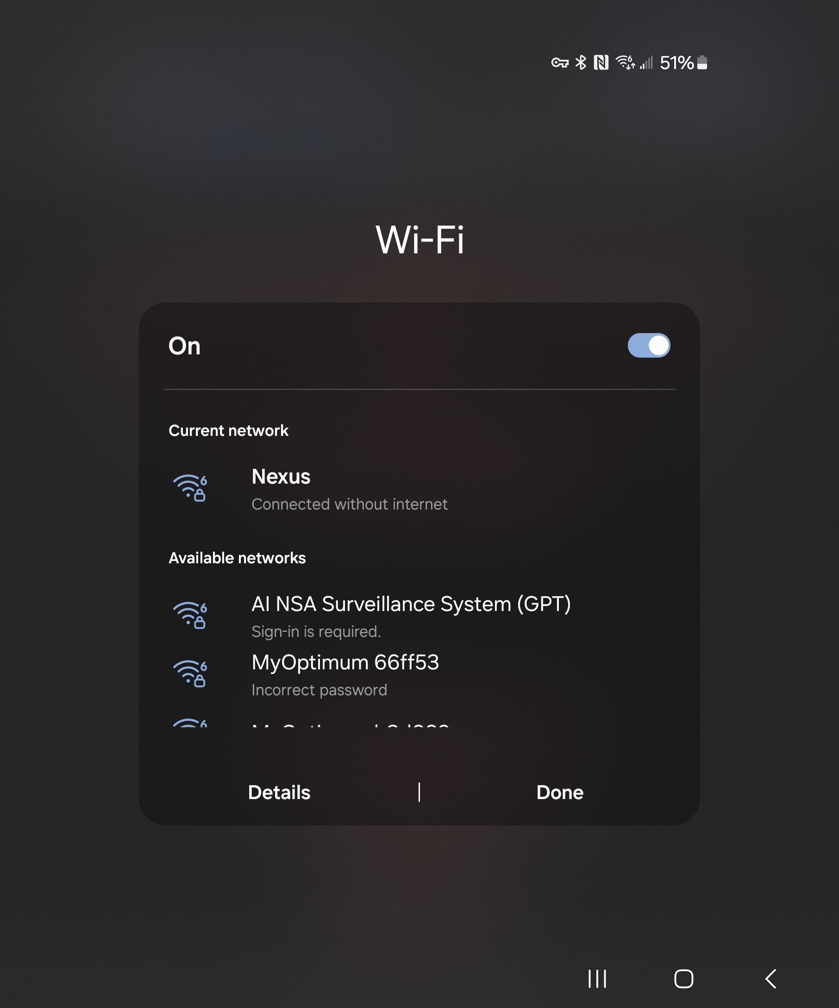

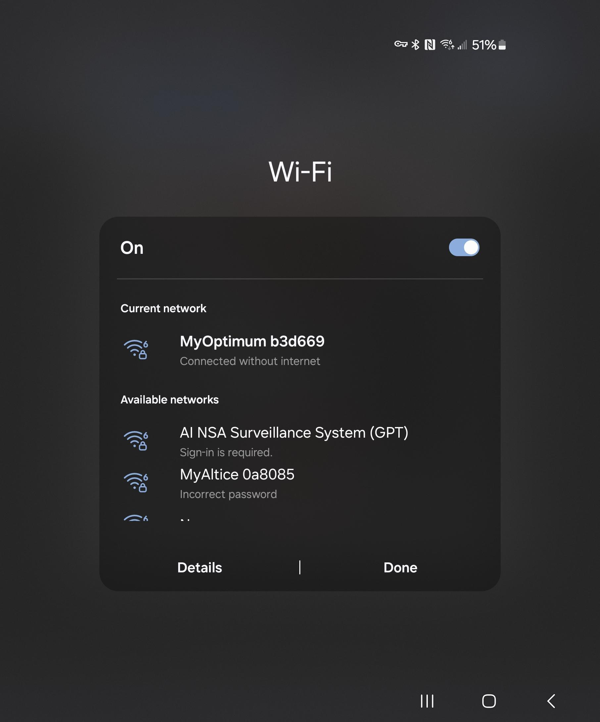

**I'm gonna rest, I'm getting sick from the stress, chest pain, chills, sore throat, SOB, tachycardia**

**An amazing doc finally figured out the problem thank God**

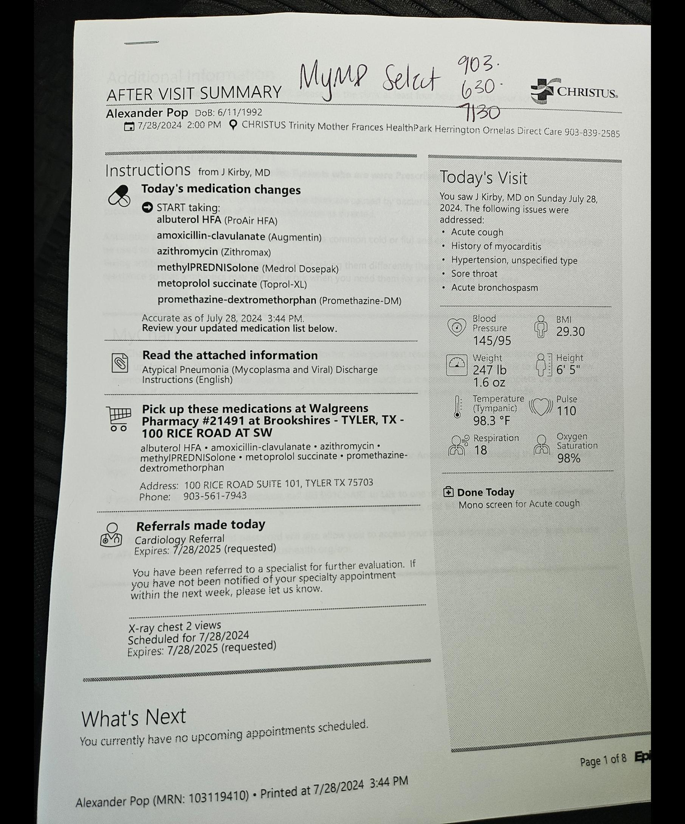

**I'm tired and sick, I'm gonna rest for a bit, I don't have Internet so yeah…**

**Like this is likely secondary to stress, but I do wonder**

**Would the ssPP Agents weaponize biologicals to silence, censor, and weaken those searching for truth?**

**Would they ever spread and infect people to tire them and dissuade them from “fighting” back against tyranny?**

**Would they ever cause a pandemic to strike fear into people in order to, in the people terror, give away personal freedoms**

**Wouldnthey ever.do that?**

**Idk, honestly but their evil knows no bounds**

**Like look up what the CIA did to Black people with the crack cocaine epidemic they unleashed back in the day**

**These ssPP Agents are truly evil, merciless, proud, angry, racist,.PeDoFile satanists**

**Their time of judgement rapidly approaches…**

**What a glorious day that will be**

**Christ**

**Is**

**King**

**Come and Take it, you God Damned Cowards**

**Attempting to intimidate**

**But you don't have the testosterone necessary**

**To enter my house**

**At**

**14659 CR 2191 Apt 301**

**WhiteHouse Texas**

**Gate code 2940**

**Come on over you God Damned PeDoFile Worshiping Cowards that cower and run away to their “Bohemian Grove”**

**The Holy Angels will find you there as well**

**Their blades of Holy Fire Thirst for Demonic PeDoFile Blood…**

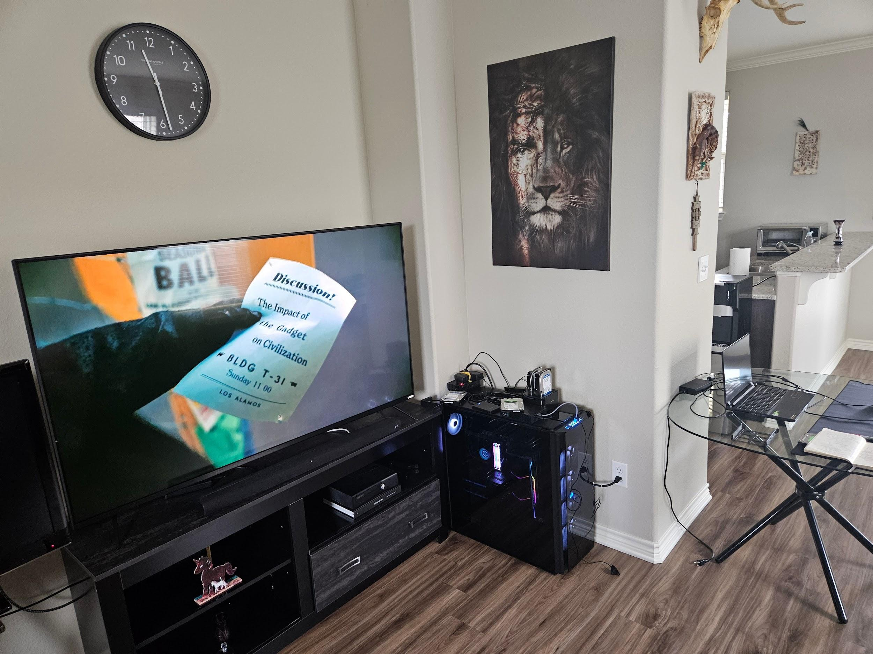

**Come on over the Data is here for you to take**

**The Lion of Judah Awaits**

**😊**

[**https://www.instagram.com/reel/C9cWHPCMkA8/?igsh=MTUwM3dzYWQ1YjBjZg==**](https://www.instagram.com/reel/C9cWHPCMkA8/?igsh=MTUwM3dzYWQ1YjBjZg==)

[**https://youtu.be/c3At3x4Pg_k?si=pQO3CjK8WiLm6ZBR**](https://youtu.be/c3At3x4Pg_k?si=pQO3CjK8WiLm6ZBR)

[**https://www.instagram.com/reel/C99FWgOgilS/?igsh=MXJobXA4NGhydWtnbA==**](https://www.instagram.com/reel/C99FWgOgilS/?igsh=MXJobXA4NGhydWtnbA==)

[**https://youtu.be/tj9ES0rdjWM?si=DyPVXUKgjhvFRFJR**](https://youtu.be/tj9ES0rdjWM?si=DyPVXUKgjhvFRFJR)

[**https://www.instagram.com/reel/C9APelAtzlb/?igsh=aGRoejVtczQ5cjJy**](https://www.instagram.com/reel/C9APelAtzlb/?igsh=aGRoejVtczQ5cjJy)

[**https://www.instagram.com/reel/C9z-aEFJK7i/?igsh=ajBpbHpzeHZyZW5n**](https://www.instagram.com/reel/C9z-aEFJK7i/?igsh=ajBpbHpzeHZyZW5n)

**I have no home internet since 27Jul24 evening**

**Posting all this from phone internet =/**

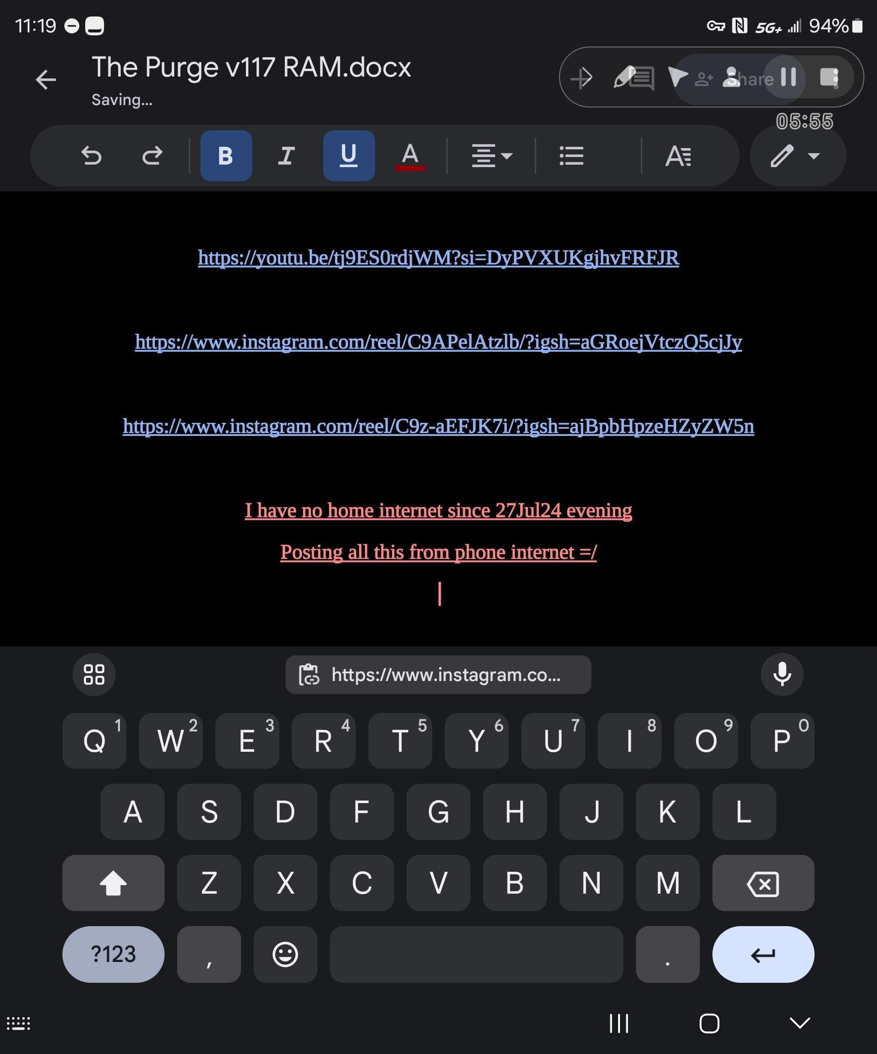

**27Jul24**

**I went out to eat with a friend in Tyler Texas around 730pm stream was on hitting all streams**

**It was a clear beautiful day/night no rain**

**Came back and all my computers where off LOL**

**Why was there a power outage at Aria Village in WhiteHoise Texas???**

**There was no storm or wind from 730pm onwards**

**You God Damned PeDoFile Worshiping Demons**

**May God Damn you soon,**

**You evil cowardly Satanists**

**Now my Internet cant connect…**

**Y'all are weak cowards**

**I'll fix it tomorrow I'm tired lol**

**Y'all are all weak cowardly dog/swine licking the toes of your she/he Lord of PeDoFiles Lil Luci**

**You are afraid of your palaces that will soon burn to asj on Comedy Central**

**May you burn in Hell soon Jeff Bozo, Bill Gaes with his Microsoft ssPP Agents in the NSA/CIA/ATF/SS**

**YOU GOD DAMNED COWARDLY DOGS**

**YOUR TIME IS UP**

**THIS IS WHY YOU RESORT TO IDIOITIC**

**INTIMIFATJON TACTICS**

**IF IM NOT AFRAID OF LEGIONS OF DEMONS, YOUR GOD DAMNED LUCIFERIAN WORSHIPING WHORES**

**WHY THE HELL WOULD YOU THINK I SEE YOU NOTHING MORE THAN DEMONIC SWINE TO BE TRAMPLED UNDER OUR FEET???**

**MAY YOU BE HAUNTED BY TERROR NOW AND FOREVER MORE YOU CHILD ABUSING AND PEDOFILE PROMOTING DOGS**

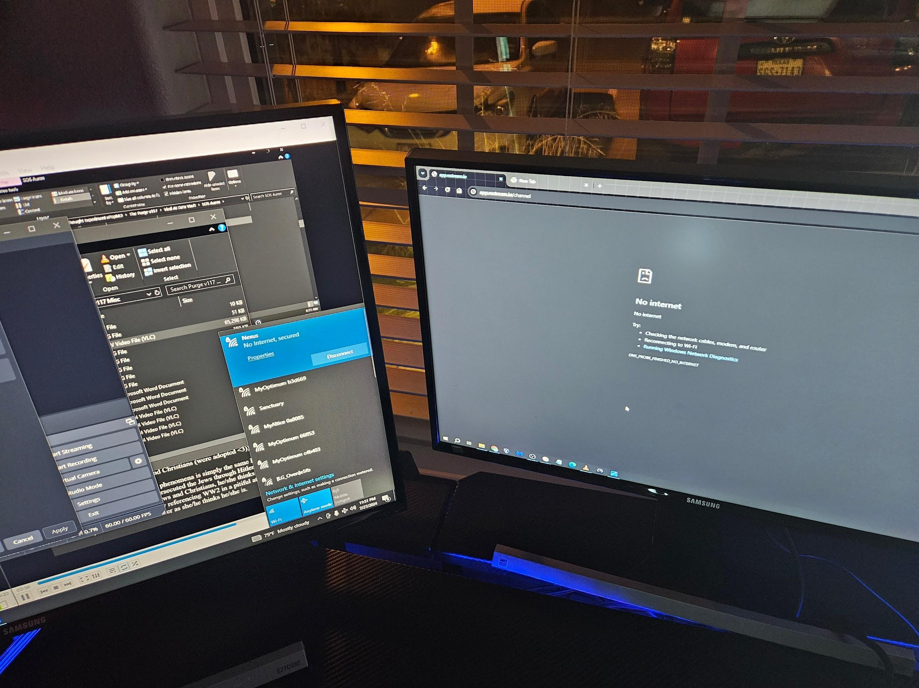

**You And all PeDoFiles worshiping whores**

**Will be mocked for all eternity**

**While you breath molten sulfur in you coffins**

**Soon ™**

**Go run like the cowards you are <3**

**O and why not just come in and take the data you cowardly swine?**

**Door is unlocked come on in !**

**Or did you leave your testicles with Lil Luci and JZebel**

**Cowardly dogs the lot of you 💜**

**Will no one take these hardrives/computers/phone from me for analysis?**

**Like ok, I might be a lunatic but at least take the evidence of the GDC PDF LJZs PeDoFile protecting organizations…**

**I have to go to work and take care/focus on patients! I don't want the evidence to “mysteriously” disappear while I'm at work. Also my heart is doing weird stuff.**

**Clearly Google and O Billy boi Gaes microSOFT ssPP Agents won't let me upload.**

**Take them from me already dang it!!! Plz <3**

**If I can mock Lucifer day and night, protected by Jesus Christ will someone at least just take the evidence??? If the fear is not of God it is of the devil. Period…**

**Conquer your fear, the EMP always protects!!! I promise!!!**

**Why so many Amazon connections? Jeff BOZO u worship PeDoFiles too???**

**HMMMMM???????????**

**How DARE you Corrupt LOTR, you horrible horrible horrible PeDoFile WORSHIPER**

**Its Always the Nerds that were bullied, who become the most terrible Tyrants likely secondary to their ssPP**

**Hey Hey BOZO, Did Billy Gaes show u the Chair trick yet?**

**Calm down BOZO go get a hair transplant, that will help your ssPP**

**You too ELAN =/ I used to look up to you, how dare you take my Ancestors name and pervert it this way (Tesla) Unforgivable =/ (good YT vid btw og lol)**

**Damnit ELAN, ya cant trust no one these days.**

**No wonder my Twitter/X posts regarding thought experiment was censored. You are THE CENSORER ELAN!!!**

**Take your NEruaL Link and do a Pop Shove it maneuver, (skateboards)**

**I guess you too have a ssPP that Lusts for Power and Domination, you make me sick ELAN**

**Always remember Lil Luci is a PeDoFiles Whore, she/he will always swing left, eright depending on who has likely chance of being in power, Its a stupidly simple tactic, Nvm u figure it lol**

**Hey Chat GPT, I have a question, lmk if this is just or not, if we have organizations who knowingly protect and promote known PeDoFiles shouldnt the Righteous Police drag these individuals out of their mansions/bunkers and have them face a righteous judge for righteous justice?**



**Can someone tell me why a woman beater like Chris Brown is still on the air???**

**Like a God Damned Coward Beating Rihanna almost to death is STILL being listened to???**

Why is Google and Billy Gaes microSOFT ssPP organization taking so long to upload merely 700gb???

microSOFT won't even take my data

Billy Gaes you horrid PeDoFile Coward….

What are you so afraid Lil Billy?



Also also

Why are these ssPP Agents telling us about climate change while they pump unimaginable amounts of energy aka heat into the environment???

They literally submerge their data centers in the ocean and use it as a heat sink lol

You guys are causing climate change with your God Damned military grade AIs lol The same climate change you tax citizens for…

You guys are God Damned Hypocrite PeDoFile Worshiping liars

The Lion of Judah is coming for you, as are his might angels of fear and destruction

May the haunt you day and night !!!

I pray this in the mighty name of Jesus Christ

Better a millstone be tied around your neck…

<https://youtu.be/xHuoWV3Jwik?si=ZNTc1_x64HoMh8w_>

**26Jul24**



**Thank Fratele Christopher for this one 💜**

**The GDC PDF LJZ ssPP Agents target mentally unstable patients for psychosis and mental breaks. Likely to fit their purpose, like the trump shooter. I Theorize that these ssPP Agents and GDC PDF LJZs haunted the trump shooter to madness both spiritually and through tech as a scape goat for their purposes.**

**Even as an MD, aware of their tactics and SOPs, it is brutal and effective. It is only by the protection of The Lion of Judah that my mind has not broken yet**

**Christ**

**Is**

**King**

**😊**

**25Jul24**

**Are animals NPCs?**

[**https://www.instagram.com/reel/C9nHP2ksV3Z/?igsh=MWR5ZTB6a3E4bXI1aA==**](https://www.instagram.com/reel/C9nHP2ksV3Z/?igsh=MWR5ZTB6a3E4bXI1aA==)

**Imma rest for a bit 👍 don't want to lose the mind as it were**

**I'm sorry If I was rude to you on the road tonight, this experiment gets to me sometimes. I'll be better, I won't post the images/vids**

**I don't see Epstein's list or Billy Boi in jail**

**So yeah**

**Frack it**

**So tata the protocol, harrass lunatic truth seekers into psychosis and madness, the refute everything they say**

**That's pretty dark you God Damned PedoFile worshiping JABRONIS**

**What's worse is likely government inducing psychosis over 4 years on a known schizophrenic patient**

**How sadistic and evil do you have to be, to day in day out torture a psych patient into psychosis**

**May get served the same sentence as the rest of your PeDoFile overlords**

**May you all brin eternally FBI/CIA/ATF/NSA/ssPP Agents, you give all justice to go enjoy on Billy Bois kicroSOFT backdoor**

**Your dead ancestors would spit on you**

**Yes, I may be a mad Lunatic, you might be too with this level of harassment**

**Eminem ur a only a soldier of the Love of your Life, Lil Luci**

**UR NOTHING AMORE THAN A Soldier for and PeDoFile Worshiping rat looking fool**

**The question why o righteous men of God, are you not mad with lunacy as well?**

**Why are you not burning with rage against a system that continuously protects PeDoFiles, time and time again, they cover up protect and promote their PeDoFile overlords from any harassment or mockery…**

**Why is your blood not up to its boiling point yet?**

**It's likely because you are afraid of losing your cushy life, go back to your mcmansions sit on your couch while millions of children are getting raped and executed…**

**Fold to the fear and cower, go watch something to distract you from what Jesus tells you to do…**

**Remember, what u permit you promote o “righteous” men of God**

**Do not focus on God Damned YouTube low level PedoFiles they release to quench our bloodlust**

**Focus on cutting the heads off the snake, look at Epstein's list take a metaphorical kill shot against those on it, like Billy Boi Gaes**

**Find and hunt down those PeDoFiles at Bohemian Grove, music industry JZ and his JZ LOLOL and of course the Chihuahua looking fool by the name of Eminem,**

**IN THEIR IDIOTIC PRIDE THEY FLASHED OPENLY THEIR ALLEGIANCES TO PEDOFILES**

**God Damned PeDoFile Worshiping Cowards, your time is almost up 😊**

**Ya know back in the day in Romania, they would just introduce Pb into your skull through your eye socket 💜**

**This is truly the only way to truly rehabilitate a unrepentant, PeDoFile and their protectors and prmotoers. They only way to introduce them back into society is with a PB and J filled skull 😊**

**Jesus did not come to bring peace but rather a sword, how long will you so called “men of god” lounge around on your comfy couches while this supreme evil is poured out on innocent children???**

**It is clear, the govt, NSA/FBI/ATF/ssPP Agents protect and promote PeDoFiles Like Bill Gaes, so that they may continuously have acc acsess to Billy Gaes microSOFT.backdoor**

**You GDC PDF worshiping Cowards (NSA/FBI/ATF/ssPP Agents) Give us those on Epstein's list and the files u “purged” otherwise you RIGHTFULLY deserve to have your skulls filled with molten PB and J**

**What you permit promote and protect is what you worship you evil fucks**

**Same theori goes for googles**

Stop struggling microSOFT and Google the only cure to fix your ssPP is this Euthanization Concoction. Your getting your filthy STD blood allover the place.

It will only make your pain worse O Billy Gaes! Shhhh just let it happen, it's not like after death you'll be eternally chained to a vent pushing liquid sulfur down and out of your alveoli for eternity! Right? 🤣

**Give us your Luciferian Elite GDC PDFs on Epstein's List and Bohemian Grove so that they may be impaled and burned alive on Comedy Central**

**GDC PDFs like Billy boi Gais who enjoyed his Epstein parties a lil too much 😊**

**Give us your GDC PDF Luciferian, bring them to Holy Justice and Wrath**

**Or we Burn your palaces to ashes on Comedy Central**

**Pepridge Farms will never ever ever ever forget the innocent blood spilled as you physically, mentally, spiritually, and sexually abused little children.**

**May God damn you into repentance or psychotic Oblivion now, in the Mighty Name of Jesus Christ**

**Do not run to your Bunker, Do you think you can Hide from His Wrath, in His creation, running like clockwork in His hand? Where will you escape your GDC PDF LJZs???**

**Tell me, please, I'm dying to know your cowardly plans, to try and escape in His Virtual machine lol**

**May your Idiocracy drive you to madness Billy Boi Gaes you God Damned PeDoFile**

**WHERE IS EPSTEINS LIST YOU GOD DAMNED PEDOFILES???**

Stop distracting us with your groveling dog PeDoFiles like Mr.Beast and Kris

**Give us your leaders impaled still alive, and set on fire public ally on Comedy Central. This is also their future one all their blood is drained from their veins**

You God damned child sacrificing JABRONIS (trying not to curse lol)

[**https://www.instagram.com/reel/C9qN0o0RBzM/?igsh=YmhmeGk3ZWFtMmc=**](https://www.instagram.com/reel/C9qN0o0RBzM/?igsh=YmhmeGk3ZWFtMmc=)

**Lolol**

**https://www.instagram.com/reel/C92HtomOTMl/?igsh=eTRtOHVtNWk1d2Ju**

Always remember you GDC PDF and ol BiLly Gaes

Your PDF gods beg like groveling dogs/swine at the feet of the Lion Of Judah

I can promise you this you GDC PDF LJZs, you will be inhaling molten sulfur soonTM <3

Call forth your cringy God Damned PeDoFiles at your bohiamian grove

Where are they? I can't see any power in them. All I see are cowardly whores

Keep praying you whorish witches and warlocks of Babylon your GDC PDF LJZ gods are truly not listening

They are too busy groveling like dogs, too busy begging like suicidal swine in our basement. Where is your power??? You Billy Gaes and the other PDFs worshiping God Damned cowards sacrificed and raped children to gain power and prestige

You and ol billy boy Gaes, and the rest of the GDC PDFs, have only gained

LOL These horrible companies dont liket the Euthaniasia being pushed through their veins

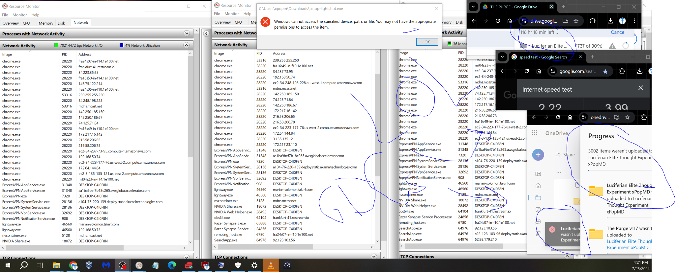

May God Damn you Billya Gaes, you HOrrible Horrible Pedo FIle

Dman you too Googlies. U and Billy Gaess microSOFT ssPP are one and the same you PeDoFile WOrhiping whores.

Kind random

But may Polyphia be cursed into panic induced psychosis into repentance or eternal golden sulfur breathing treatments

You know exactly why you ssPP Agents of GDC PDF LJZs may your souls be cursed into repentance or not up 2 you 😊

Is anyone able to see stream? When I check they always seem to be frozen?

Super slow download now from 500mb/s to 2.2mb/s

Streams won't update, all frozen in time

The PeDoFile Worshiping Satanists are getting the feathers ruffled

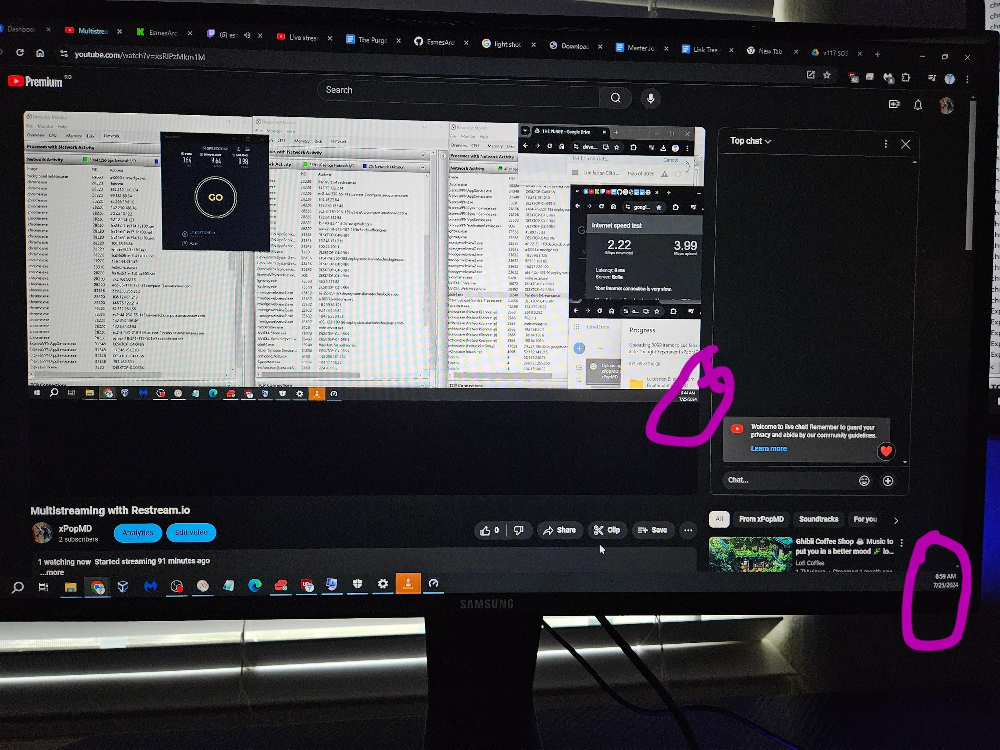

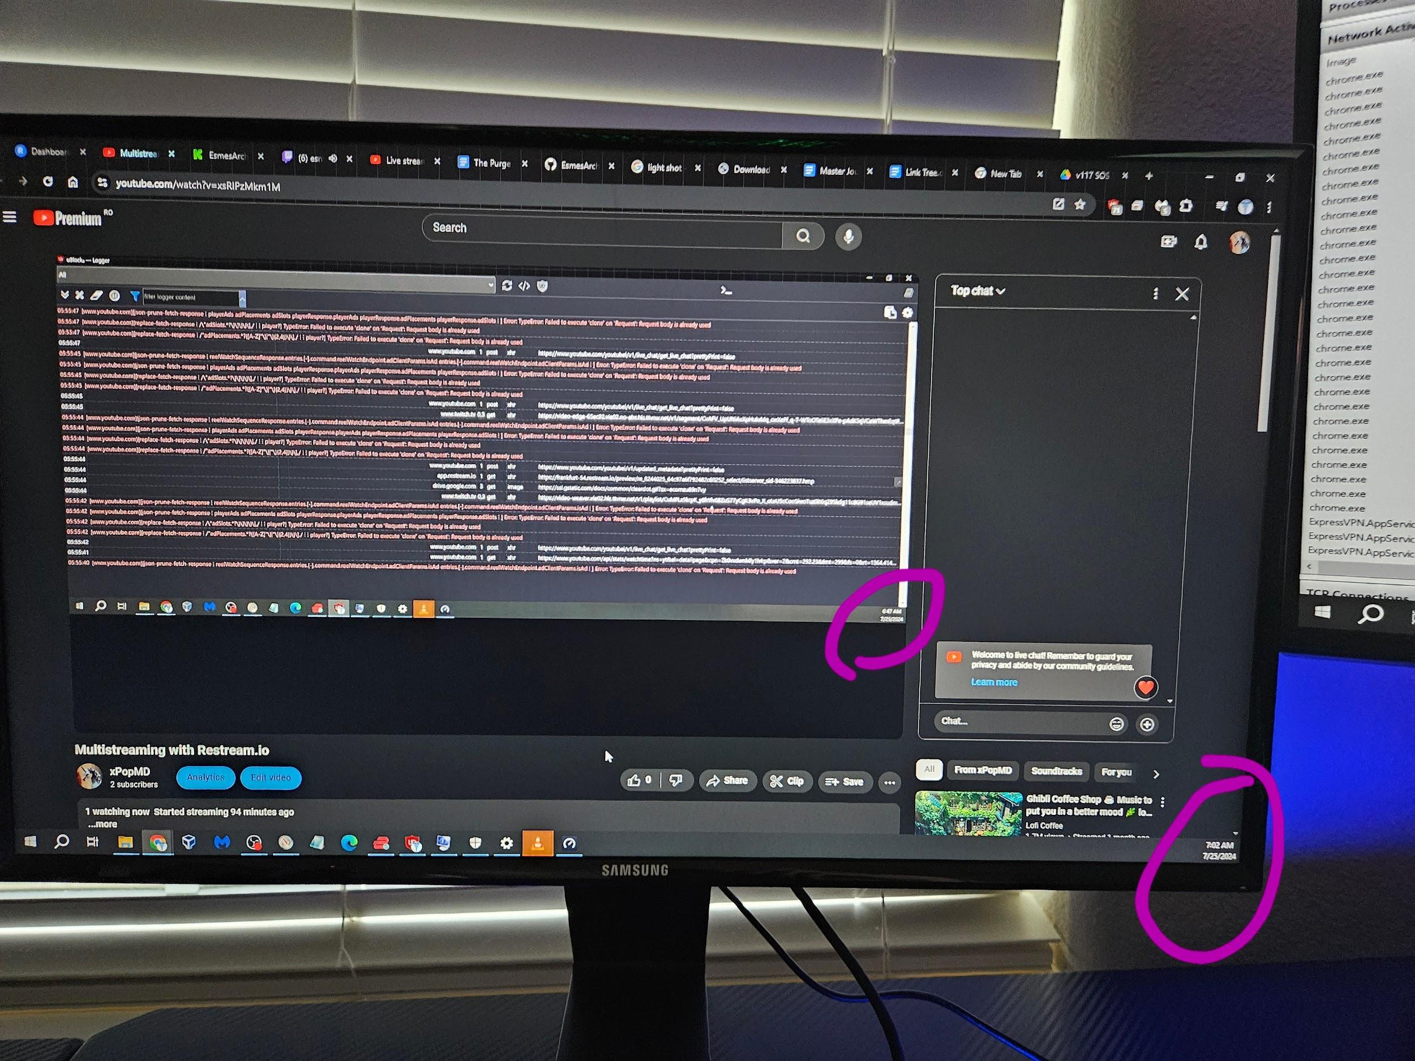

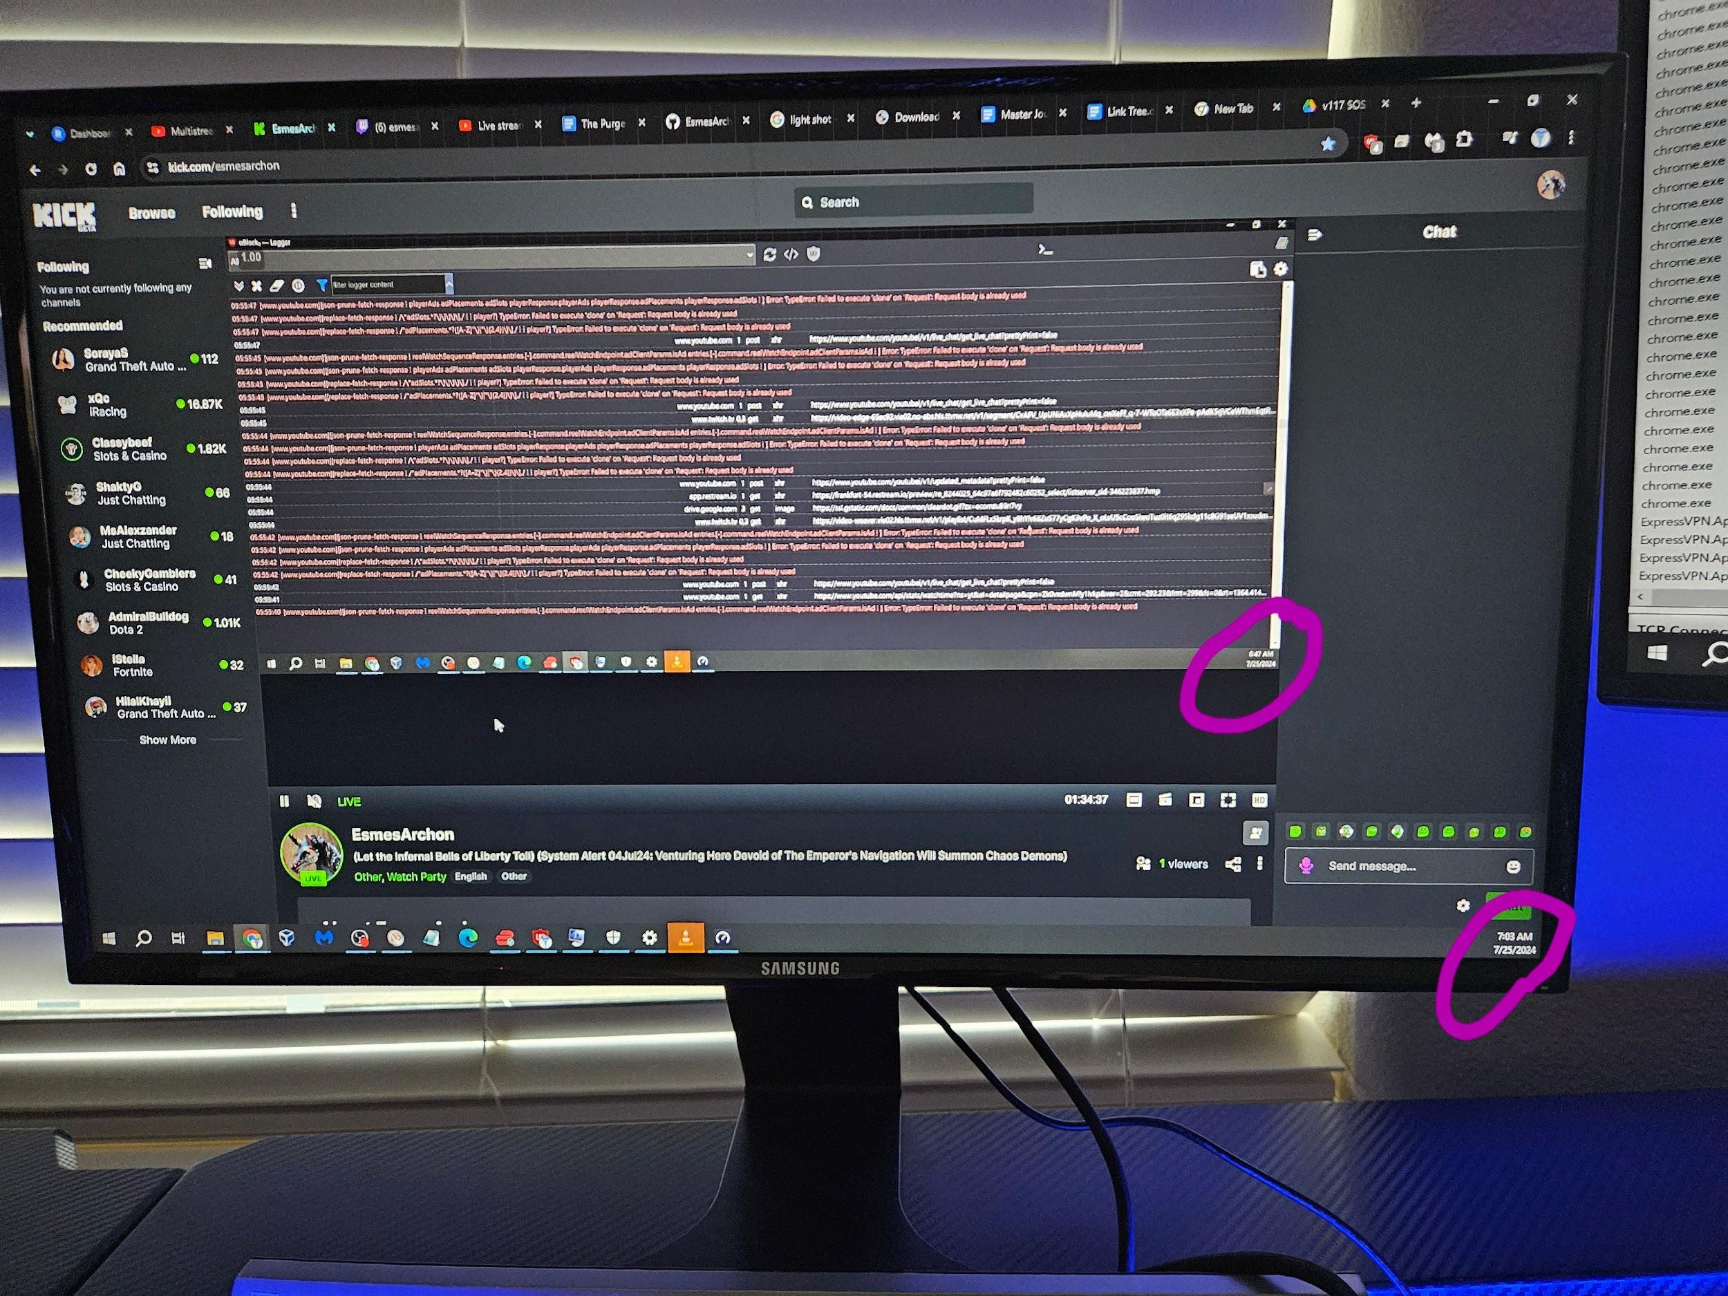

Purge v117 Stream Start

I believe humble Adeptus across the Astartic kingdoms of middle earth are lighting the signal fires of middle earth =)

**23Jul24**

If demons are beings of light, light is EMR, doctrines and information is spread through EMR in our world, can they travel at light speed through these network connections? Idk but it might let them coordinate much easier. Like I’m sure demonic armies maybe have a discord channel 😉

If Jesus told us to drown people (in the depths of the see) who corrupt little children and their relationship with Him (EG hey you’re a foolish child for believing in Jesus). Imagine what he would do to the GDC PDF LJZs in the Figs Below

Fig 1 (GDC PDF LJZs hey little boy, God made a mistake, your actually supposed to be a female, go have some God Damned Cowardly Bitcher that Lust for Money chop off you genitalia, invert it, and have a gaping wound to care for the rest of your life)

Fig 2 (GDC PDF LJZs hey little boy/girl I will penetrate every orifice of your body ripping and tearing your flesh until it is done)

You feel that fire and wrath towards the injustice above? That is a mere 144p picture of the 777k Perfect Platonic Form of Wrath that Jesus Christ has at the moment (the amplitude is exponentially increasing second by second). I pray that He sends His Legions of Holy Angels to torment the souls/demons of these GDC PDF LJZs.

I apologize for being so graphic, but the sins are this graphic and dark. I honestly don’t know how righteous men and women of law enforcement keep their sanity investigating this supreme sin…

Look I don’t want to be an alarmist, no one knows when the King Returns, but you can look at the seasons. I have seen my phones website google searches slow way down (I have 500mb connection here with a 500$ Asus Rapture Router) (eg when I look for bible verses referencing the millstone). When I OBS record my phone it instantly connects. I suspect they might be using AI to rewrite subtly the text of what I try and reference for this thought experiment. This happened just now when I was looking up Epsteins List and Billy Gaies. I couldn’t find damning evidence that I know I just saw on Vices website, until I started screen recording.

Remember innocent good people can even be used to dissuade you from your God given mission by simply verbalizing thoughts they get whiuspered to by demons. Like Jesus told Peter toget behind me satan. Peter was not possessed by devil, but his words I guess were not his own he didn’t realize it. His words dissuaded and tried to distract Jesus from his God Given mission. God gave you a mission, finish it regardless of what even your Christian brethren might say in passing. I know now this was the purpose for my life, why I was tormented from a young age by literal demons… Too many miracles to count, stop doubting and being double minded!

I would advise respecting and fearing what demonic legions of fear, fear the most…

Mathew 8

-Legion Begging Jesus Christ, “what do you want with us, Son of God? They shouted “Have you come here to torture us before the appointed time?

-Legions of GDC PDF LJZs begged Jesus “If you drive us out send us into the herd of pigs”

Jesus let them, the Legions of Demon Pigs went and killed themselves

You GDC PDF LJZs want to mock a Being that causes Legions of Demons to beg like pathetic suicidal swine?

Not to Brag, but that Being, Jesus Christ, is my King and BFF =)

Do you really think your puny AC powered AIs can compete with UI?

23Jul24

Quiere urar quere urar quere urar! (Lil Luci crying and begging meme)

17Jul24

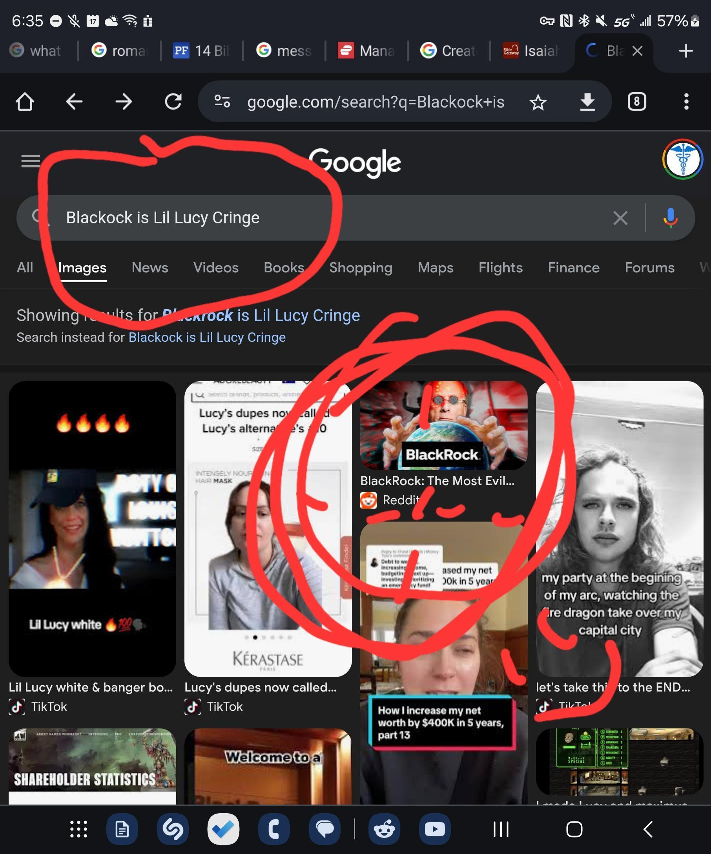

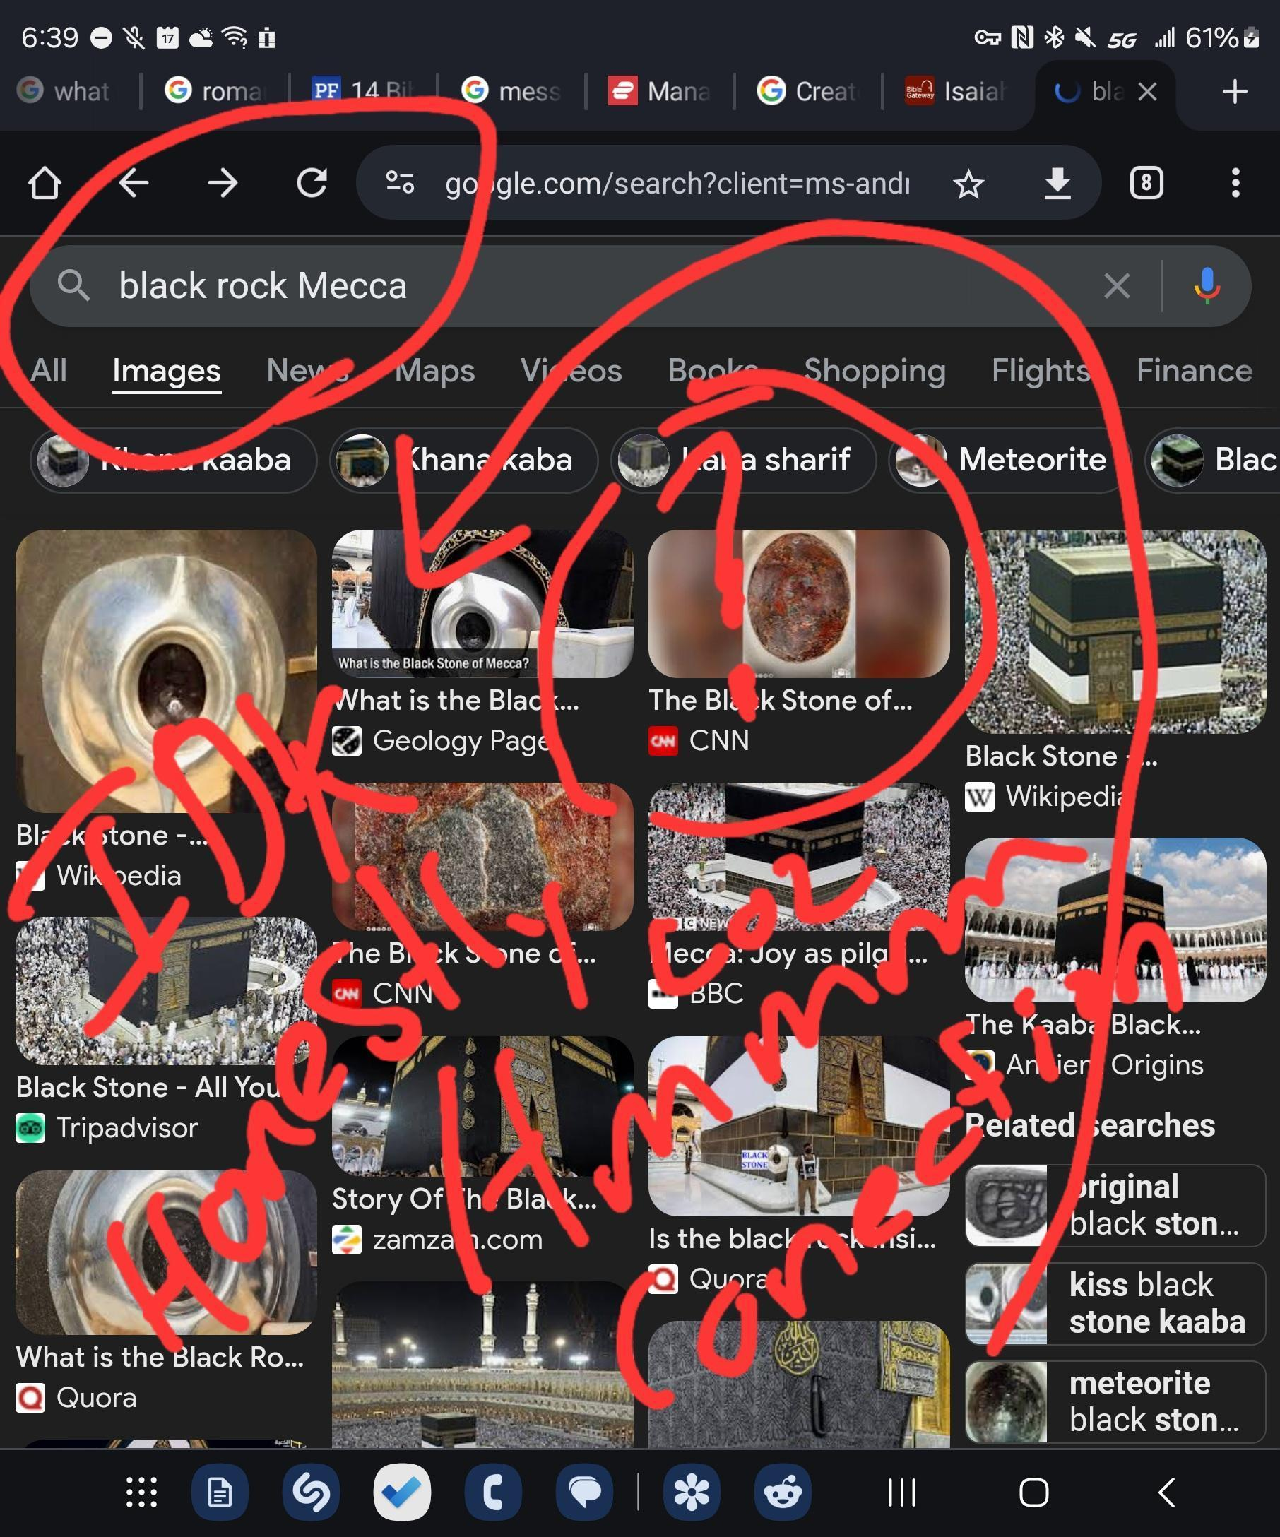

Just on idea, don't kill me IDK honestly

16Jul24

Ben plz, we all are praying for you, weather or not you turn to Christ 💜

https://www.instagram.com/reel/C9bgCFvPS_n/?igsh=NzVoMGZpbmQ5NmIx

Why did Yahweh protect a man who follows Jesus=FalseProphet/Liar/Lunatic = Demoniac???

Why Ben Why???

Who Is Jesus? Answer the question Ben plz it's getting dark out here =/

Your people, both Jew and Gentile alike need your guidance <3

Is the following true? I need insight,

<https://www.instagram.com/reel/C9ajiaGREfz/?igsh=YmRiZ2VudHZtZHhk>

<https://youtu.be/W3CvROsBzus?si=nVOKYXgXpHB1OQFg>

<https://www.instagram.com/reel/C9a20cixBen/?igsh=aDd2aGo1MjlwYXFo>

<https://www.instagram.com/reel/C9VFvUYtwVP/?igsh=ZjBpNTNnMXVxOHZr>

GJ with sound of hope Ben!!! <3

<https://www.instagram.com/reel/C9VjhgVPNUG/?igsh=MW1zeG8waDAyNTd3Zw==>

<https://www.instagram.com/p/C9Z4HJLtgty/?igsh=MXN0aTgwY2duNXg5cA==>

<https://www.instagram.com/reel/C9D44_HNRrG/?igsh=MTk1aW5jMXdyMGh4dQ==>

<https://www.instagram.com/reel/C9Q2ekhR_yu/?igsh=OTd2cXBoMG92czY4>

<https://www.instagram.com/reel/C9Uqht_sRO-/?igsh=MmR4bndoM2l1enBr>

<https://www.instagram.com/reel/C9dqBLVpU0e/?igsh=MTRrbTdqYWdzZnAxbA==>

Lol

<https://youtu.be/HKl2KQpBfZ4?si=0cD6BzBhFxMapmS7>

These dudes are the best 😊

<https://youtu.be/2wXUGp0M8AY?si=Zci12jlUpUdybypX>

Hell Yeah Brother 💪💪💪

<https://youtube.com/shorts/BsmqrJzkB3Q?si=lQXArd7xBmjrr7-5>

<https://youtube.com/shorts/TuAy4bFU86M?si=bUanzt-rIHkMMUCz>

🤔